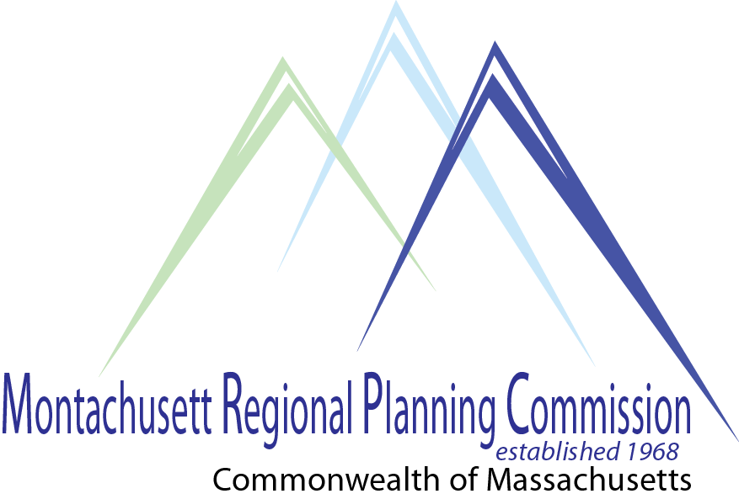
Karen Chapman
Planning & Development Director
Montachusett Regional Planning Commission
464 Abbott Avenue
Leominster, MA 01453

June 7, 2022
Lancaster Planning Board
Prescott Building
701 Main Street
Lancaster, MA 01523

RE: Planning Board Public Hearing June 8, 2022 – North Lancaster Smart Growth Overlay District
Dear Planning Board Members,
I am submitting this letter to be read into the record during the public hearing scheduled for June 8, 2022, at 7 pm as I am unable to attend. As you know, the Montachusett Regional Planning Commission (MRPC) provided technical assistance to Lancaster in the form of a District Local Technical Assistance (DLTA) Grant for planning services in 2021 and into 2022. The contract deliverables for MRPC to provide the Planning Board were: 1) Final Smart Growth (40R) Zoning and/or Village Center Bylaw(s), and 2) Information needed to submit a 40R application to the State. At a Planning Board meeting held April 12, 2021, the scope of services surrounding a 40R zoning district including the Atlantic Union College (AUC) properties was discussed and the Planning Board determined that since the ownership of the AUC was potentially changing hands, the best area of town to evaluate for 40R zoning was the McGovern Boulevard area in North Lancaster. The Planning Board turned over the town’s responsibility under the DLTA contract to the Lancaster Affordable Housing Trust (“Trust”). I am providing a summary of the GIS analysis and development of 40R application materials, including the proposed zoning bylaw MRPC completed for the project.
Officially created under MGL Chapter 40R and its implementing regulations 760 CMR 59.00, Smart Growth zoning is a tool used to encourage communities to create dense residential or mixed-use zoning districts, including a high percentage of affordable housing units. The regulations call for communities to customize a predetermined bylaw template, complete the application form, complete a density data spreadsheet calculating developable land and potential housing units for each parcel included in the district, amend its zoning map to include a Smart Growth overlay district, and utilize the Department of Housing and Community Development (DHCD) Guidelines for implementing Smart Growth zoning (https://www.mass.gov/doc/guidance-for-mgl-c-40r-and-760-cmr-5900smart-growth-zoning-and-starter-home-zoning/download).
MRPC used the DHCD bylaw template and drafted a bylaw which was reviewed and discussed over five meetings in 2021 with the Trust and the Lancaster Economic Development Committee regarding design guidelines (https://www.mass.gov/files/documents/2016/07/xn/40rdesignstandardsguidebook.pdf), dimensional and density requirements, affordable housing requirements, and allowable commercial uses. The result is what you have before you in the hearing.
MRPC’s GIS & IT Analyst, Kayla Kress, performed the parcel analysis and calculations using the spreadsheet provided by DHCD, made the necessary changes to Lancaster’s Zoning Map, and created all the maps required as attachments to the application to DHCD. Acres of developable land, underutilized land, and substantially developed land for each parcel were determined after removing environmentally constrained land according to DHCD guidelines and definitions. Removing the environmentally constrained land in the 40R application is a DHCD standard and not representative of actual delineations in the field. Any project proposed in this district that is within the Lancaster Conservation Commission’s jurisdiction is subject to the MA Wetlands Protection Act and local wetland bylaw permitting processes.
All the spreadsheet data, along with the housing unit density determined in the bylaw (20 units/acre), was used to complete the data density spreadsheet, resulting in the total number of housing units that could be developed as of right on each parcel in the proposed Smart Growth District (393 units). Please be aware that the calculation of housing units in the spreadsheet is used by DHCD for their use and is the simplest way to calculate maximum housing units (total district acres x 20 units/acre) for the incentive payment.
MRPC facilitated a commitment from the Montachusett Regional Transit Authority (MART) to add the McGovern Boulevard location to their Fitchburg/Leominster bus route #8 to allow residents to travel to locations in Leominster and Fitchburg and to the Intermodal Center in Fitchburg which provides regional shuttle buses and MBTA commuter trains to Boston.
MRPC applauds Lancaster’s initiative to provide housing for all ranges of income, along with shopping, transportation, and recreation as part of this 40R Smart Growth zoning overlay district. Some of the benefits of the 40R district are:
- Provides the community with incentive payments upon approval of application, passing of the zoning bylaw, and installation of water and sewer infrastructure to serve the district. Additional bonus payments for each housing unit given an occupancy permit is provided by the State.
- Provides the neighborhood with a range of housing and retail opportunities, as well as access to recreational activities and bus transportation to the Fitchburg Intermodal Center where the MBTA commuter rail is located.
- Conserves additional open space for recreation and water supply protection.
- Provides property owners the option of using the Smart Growth overlay district rules or using the underlying zoning rules when improving their property.
- Provides affordable housing eligible for inclusion on the town’s Subsidized Housing Inventory requiring each community to strive for an over 10% affordable housing count.
- Provides additional tax revenue.
- Allows the Town to set a path towards compliance with the State’s new MBTA Communities law for as-of-right multi-family zoning at high density.
Thank you for this opportunity to comment on Lancaster’s 40R proposal.
Regards,
Karen Chapman
Karen Chapman

